**A representation of transportation and trade networks in global energy models**

Jun Ukita Shepard, Duke University

*Email: jun.shepard@duke.edu*

IIASA Supervisor: Bas Van Ruijven (ENE) and Behnam Zakeri (ENE)

**Introduction.**

Regional energy systems are inextricably tied to international trade and shipping networks. However, current global energy models generally do not address the dynamics of these networks. These dynamics are particularly important in the context of technological transitions; shifts in regional demand will break existing trade linkages while forming new ones. In this project we explore the effects of short-term trade policies on long-term energy trade networks. These long-term trade networks not only impact energy security but can also have lasting consequences for meeting emissions targets. Understanding these impacts is therefore crucial for decisionmakers who must balance energy security with climate change mitigation.

**Methodology.**

The MESSAGE energy model represents the global energy economy using 14 representative regions. It assumes a “global pool” trade schema, in which each region exports into/imports from a global resource pool. We transition MESSAGE to a bilateral schema by specifying bilateral trade flows for five energy commodities. We also introduce shipping networks, thereby exploring the effects of trade trajectories on investment into new shipping technologies specified by cargo (e.g. crude oil) and fuel (e.g. diesel).We analyse 12 scenarios, exploring the effects of tariffs, sanctions, technological advancements in shipping, and carbon taxes on energy trade networks. Each scenario is represented in importer or exporter variable costs. The baseline scenario assumes a distance-based variable cost for exporters and a tariff-based variable cost for importers.

**Results.**

Results suggest that changes in tariff policies may change the composition of these trade flows by 2060. For instance, under a high-tariff scenario, a trade linkage in crude oil is formed between Latin America and Pacific Oceania while other linkages have reduced trade flows. Under a low-tariff scenario light oil exports from the Middle East to Southern Asia are substituted by crude oil exports and a new trade linkage forms between Russia and Africa.

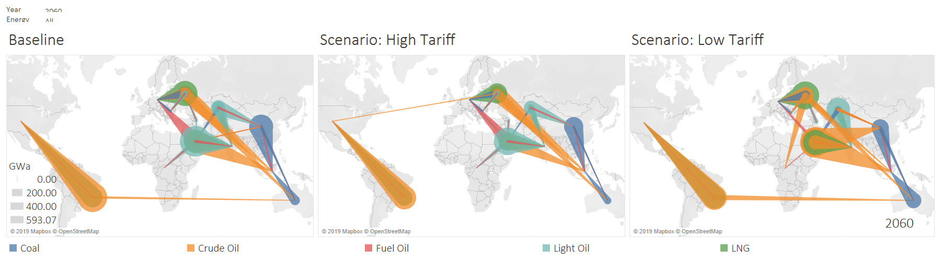

Results also suggest that sanctions between regions can have a substantial and lasting effect on energy trade networks. Both sanctions and tariffs have heterogenous impacts on regional carbon emissions; however, increased trade friction generally reduces emissions.

**Conclusions.**

This project builds on existing efforts to spatially disaggregate the MESSAGE global energy model. We introduce a bilateral framework for trade in energy commodities and apply this framework for scenario analysis. Results suggest that short-term trade policies, such as sanctions and tariffs, can shape long-term energy trade networks. This project also underscores the indirect effect of trade policies on emissions; increased trade friction generally leads to regional reductions in carbon emissions. Effects of trade policies on global emissions are marginal.